Course Project Report

MULTISCALE MODELLING OF MATERIALS USING MACHINE LEARNING

1. **Description of the Component Scale Simulation Using FEM**

The primary objective of this study is to model a “Nozzle” at a component scale using Finite Element Method (FEM) simulations. The simulation aims to analyze how variations in microstructural details, specifically grain size, affect the material’s deformation behavior under the same boundary conditions. The FEM model was set up using Abaqus with the following conditions:

* + **Boundary Conditions**: Fixed boundary condition at one end and the other has a displacement of 1 unit.
  + **Element Type and Mesh**: A 3D Tetrahedral mesh with an element edge length of 2 was used.
  + **Material properties**: the material used is ‘Aluminium 6061’ with a Modulus of 70 GPa, Poisson ratio of 0.33, Yield stress of 270 MPa, and Strain hardening exponent of 0.2.

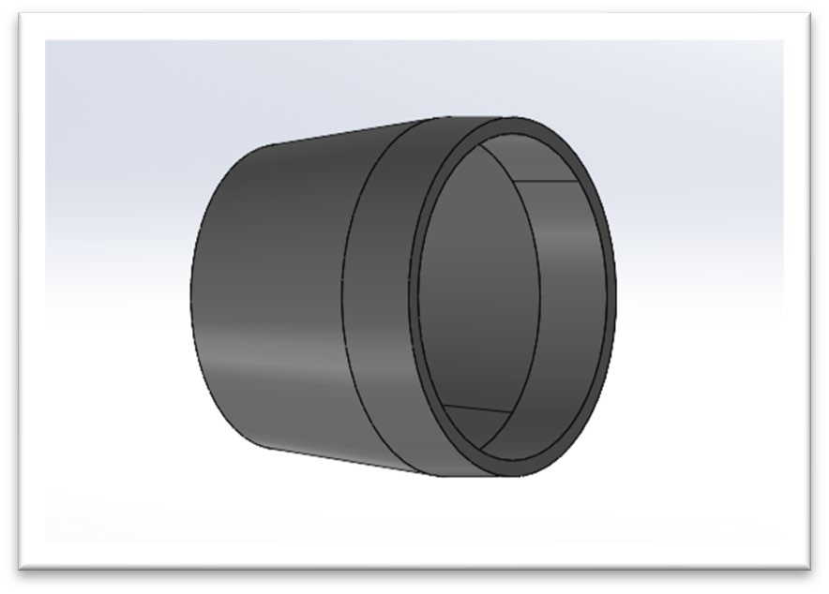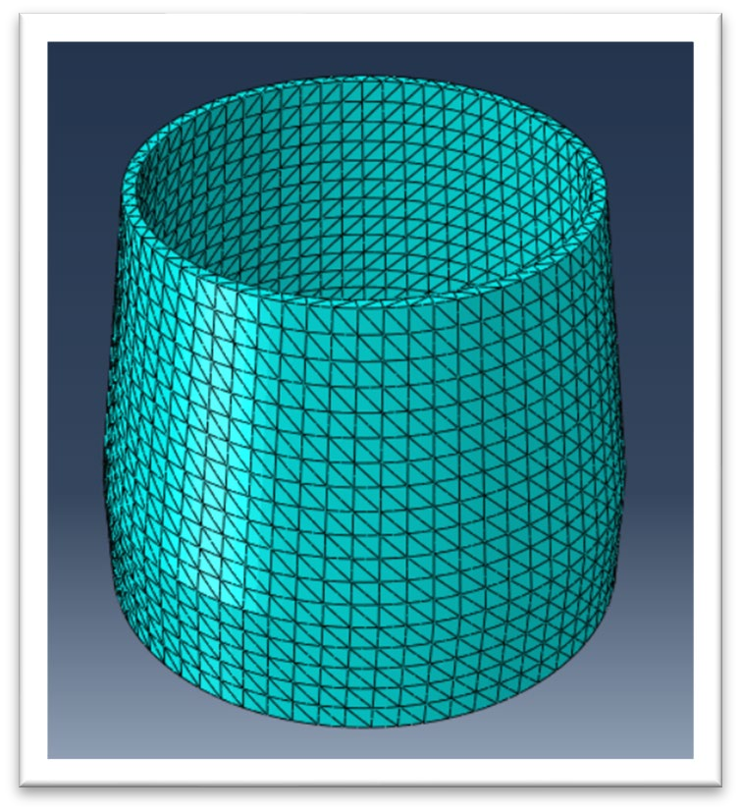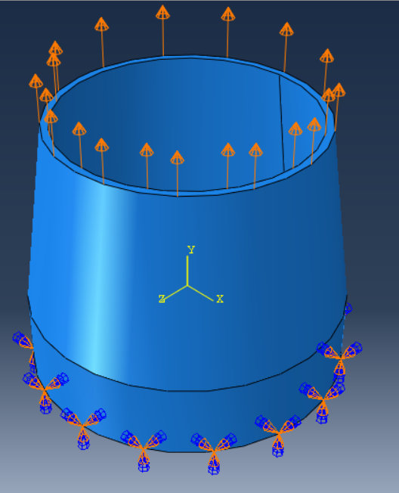

# Need for Microstructure (Grain Size) Details and Their Effect

Microstructure details, such as grain size, significantly impact a material’s mechanical properties. Smaller grain sizes generally enhance strength (due to grain boundary strengthening), while larger grains may increase ductility. Modeling these characteristics provides insight into how microstructure affects the component’s overall performance under load. The inclusion of grain size information is crucial for accurately predicting stress-strain responses and other deformation characteristics.

We took the stress vs strain plots of **strain rates ${10}^{-4} \& {10}^{-5}$** with the **grain sizes $15 μm, 35 μm, 45 μm, \& 85 μm$**  for comparing the results.

Since results can vary from element to element, simulations were conducted using an element taken from the **top, middle, and bottom** of the model and were plotted together for an even more thorough comparison.

# Concept of Multiscale Modeling: Strategy for Linking Microscale Model into Macroscale FE Platform

In this project, multiscale modeling integrates grain size effects using a **polynomial regression-based constitutive model of degree ‘2’** within a macroscale FEM simulation. This approach allows for a unified model where microscale factors, such as grain structure, inform the mechanical properties used in the macroscale simulation, creating a more accurate prediction of microstructural material behaviour.

# VPSC Model Setup and How the Microstructure is Incorporated/Accounted For

* **VPSC Model (No Microstructure):** The VPSC setup simulates the overall material response by treating the material as homogeneous, lacking explicit microstructure details.
* **ML Model with Microstructure:** Simply, this ML model incorporates grain size, which directly impacts local deformation behavior, allowing for a more detailed representation of the material. This provides enhanced predictions of strain localization and stress concentration that cannot be captured in the VPSC model.

# Details of Database Generation as a Function of Strain Rate and Microstructure

To develop the ML model, a comprehensive dataset was generated with variations in strain rate and grain sizes in which “76 simulations were generated, combining 4 different strain rates and 19-grain sizes”. Each simulation captures the material’s stress response for a specific combination of strain rate and grain size.

This dataset enables the ML model to learn the relationship between stress, strain rate, and grain size, which is essential for predicting material behavior under various conditions.

# Development of Constitutive Model Using ML

**To develop the ML model, a database of 76 simulations was generated, combining 4 different strain rates and 19 grain sizes.** We also took **60%** of the data for training and **40%** data for testing.

The ML model employs a multivariable polynomial regression approach (degree 2) to represent the relationship between stress, grain size, and strain rate which has a very good $R^{2}$ value. The final ML equation used is:

**SCAU11 = 194.7439 + (0.0*1) + (950.2556 * E11) + (97510.7493 * SR) - (0.6449 * GrS)**

**- (2227.2416 * E11**2) + (54657.1438 * E11 * SR) + (0.2969 * E11 * GrS) - (8201273.1963 * SR**2) - (12.3624 * SR * GrS) + (0.0041 * GrS**2)**

where ‘GrS’ represents grain size, and ‘SR’ is the strain rate. This model is trained on the generated dataset, allowing it to incorporate grain size effects into FEM simulations, making it an improvement over the VPSC model’s homogeneous assumption.

SCAU11



Predicted

450

400

350

300

250

200

150

100

50

0

-0.01

0

0.01

0.02

0.03

0.04

0.05

0.06

E11

Actual

450

400

350

300

250

200

150

100

50

0

-0.01

0

0.01

0.02

0.03

0.04

0.05

0.06

E11

# A Brief Discussion About the UMAT Code and Incorporation of ML-Derived Constitutive Law

SCAU11

The ML-derived constitutive law was implemented into the FEM simulation through a UMAT subroutine made for **Isotropic strain hardening**. This subroutine applies the polynomial regression equation at each simulation step, allowing the FEM solver to dynamically adjust the stress-strain relationship based on local grain size and strain rate. Unlike the VPSC model, which applies a uniform material response, this UMAT-based approach enables the FEM model to account for heterogeneities introduced by microstructure.

# Validation of FE-UMAT Code Against VPSC Simulation Results Using Single-Element FE Calculations

Single-element FEM simulations were conducted for both models, that is VPSC-UMAT and ML-UMAT, to validate the ML-integrated UMAT code. The effect of including microstructure is highlighted by comparing results from the VPSC model and the ML model.

The results at the end of the report demonstrate that the ML-based model demonstrates more localized stress and strain behavior, confirming that grain size considerations provide a more accurate deformation profile compared to the uniform stress distribution observed in the VPSC model.

# FEM Model Geometry Generation, Mesh Details, and Explicit Description of the Microstructure

As already discussed, the mesh element is **‘Tetrahedral’** with an element edge length of 2. The mesh was refined to capture the localized effects of the ML model’s microstructural properties. Each simulation was run for a total time of **100 seconds** to capture the full deformation behavior under the given boundary conditions.

In the VPSC model, uniform properties were applied across the mesh, while in the ML-based model, grain size distribution was embedded through the UMAT subroutine, simulating heterogeneous material behavior of the grain sizes from **1 $0 μm to 100μm$** with an **increment of 5,** a total of up to **19 different grain sizes.**

# FEM Simulation Results and Discussion to Demonstrate the Effect of Heterogeneous Microstructure on Deformation Behavior

The simulation results reveal that the ML-based model (with microstructure) and the VPSC model (without microstructure) produce distinct deformation behaviors.

The ML model shows significant strain localization and stress variation influenced by grain size, underscoring the importance of microstructure for accurate deformation prediction.

The comparison with the VPSC model, which lacks such detail, demonstrates the critical role of grain size and strain rate on material response, providing more understanding of how microstructure influences the material’s behavior.

# Results and Plots:

1. **Reference case (only VPSC) vs Microstructure incorporated case for a single element:**

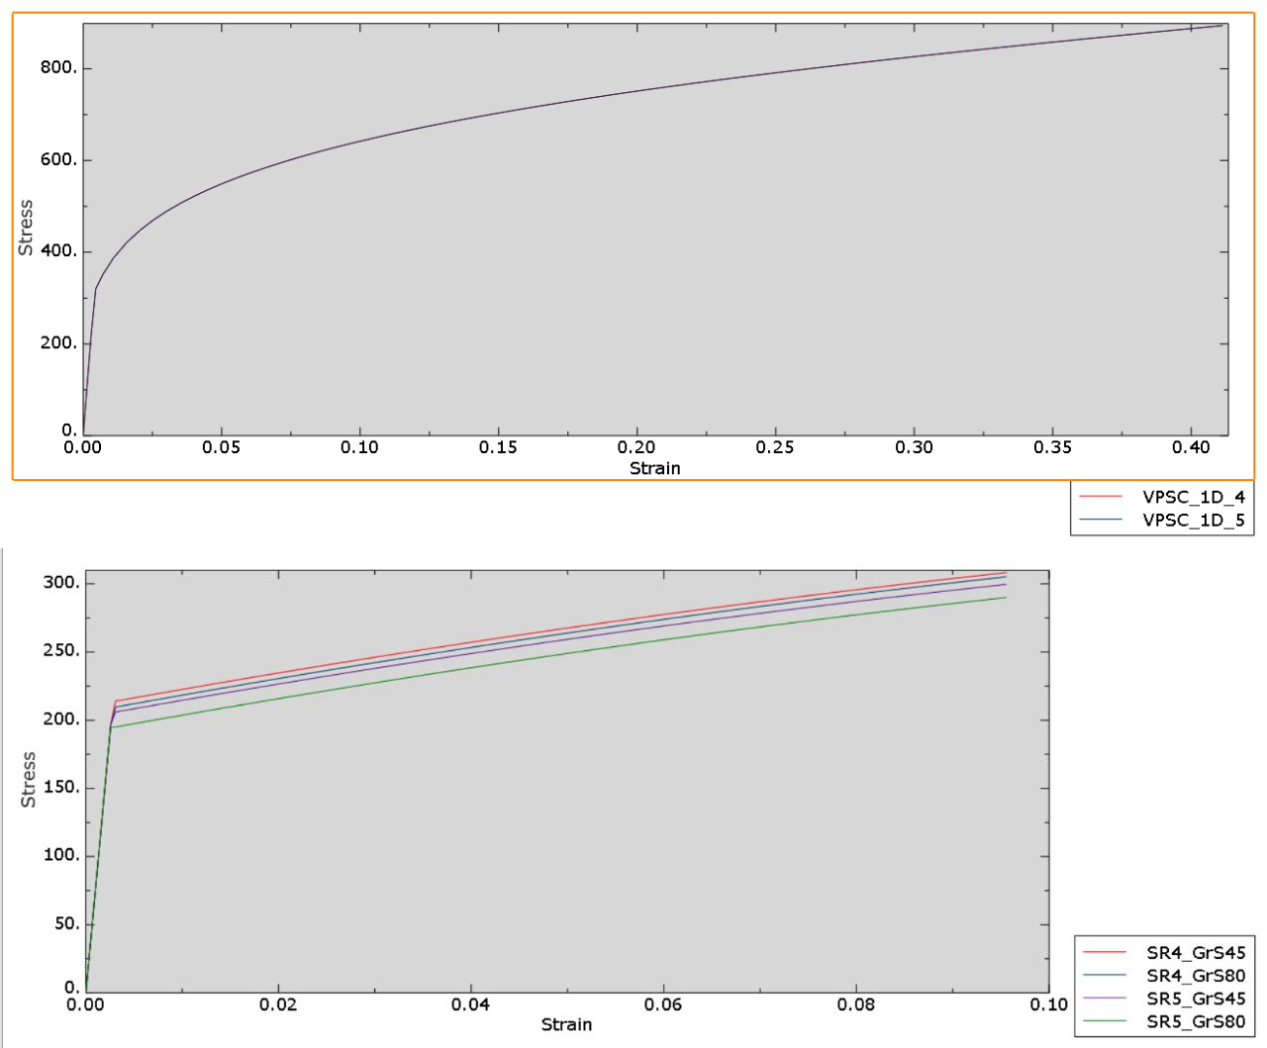

1. **Reference case (only VPSC) vs Microstructure incorporated case for the FEA model:**

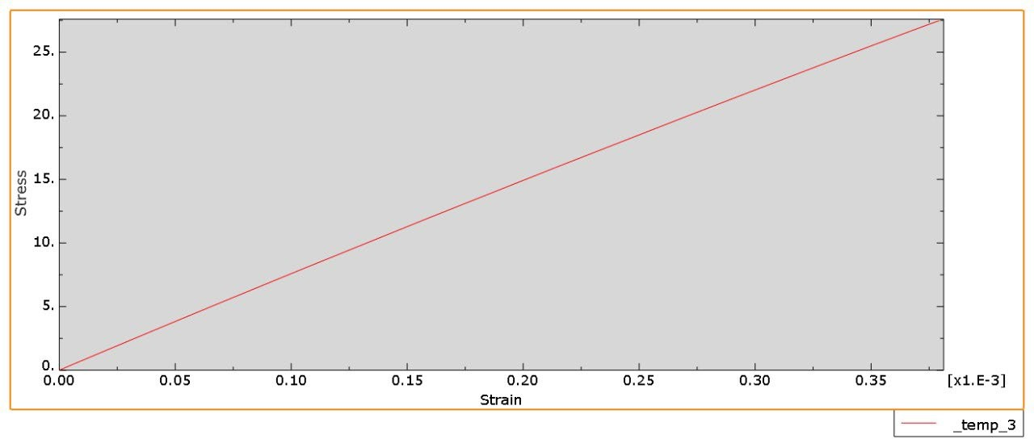

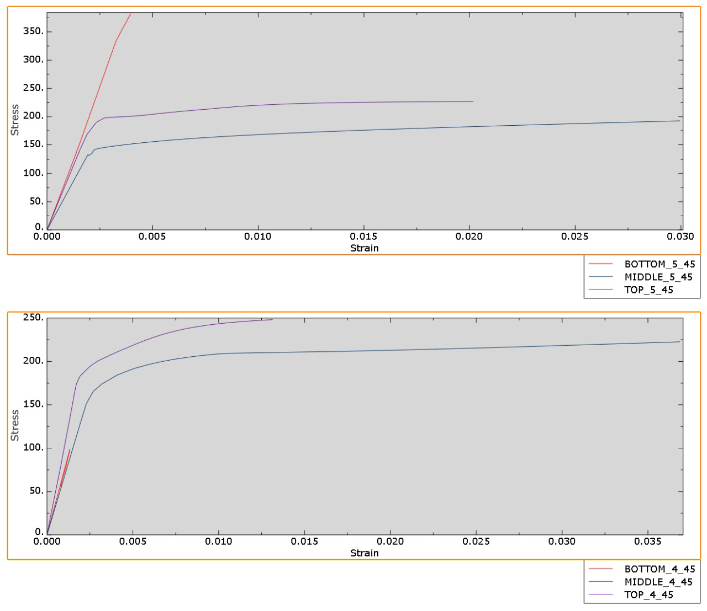

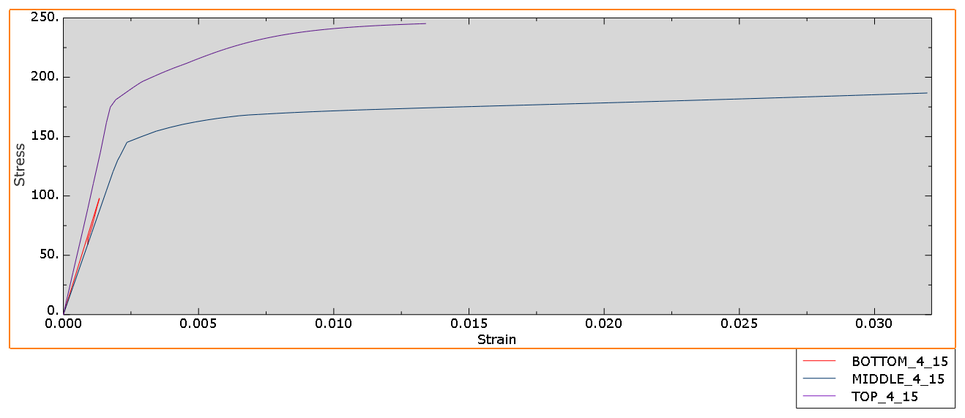

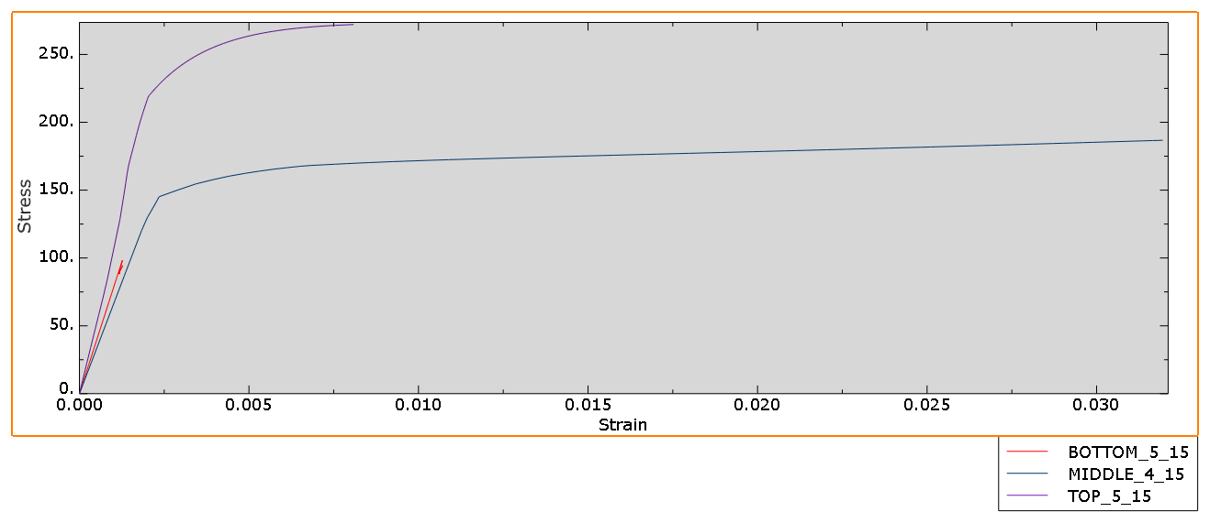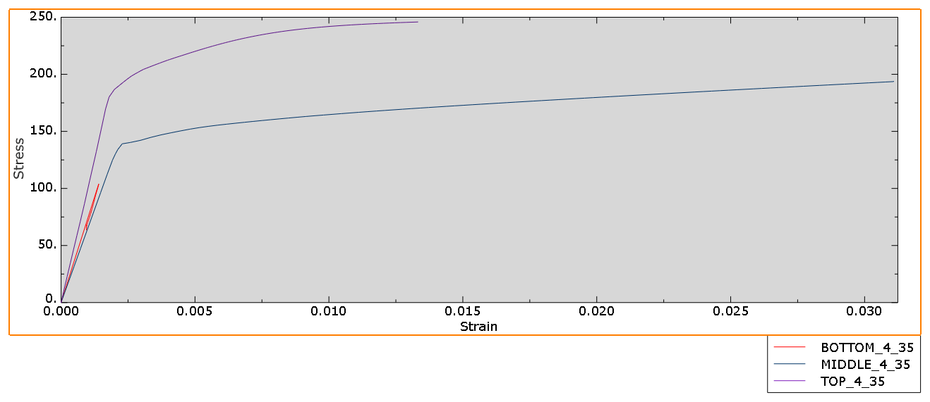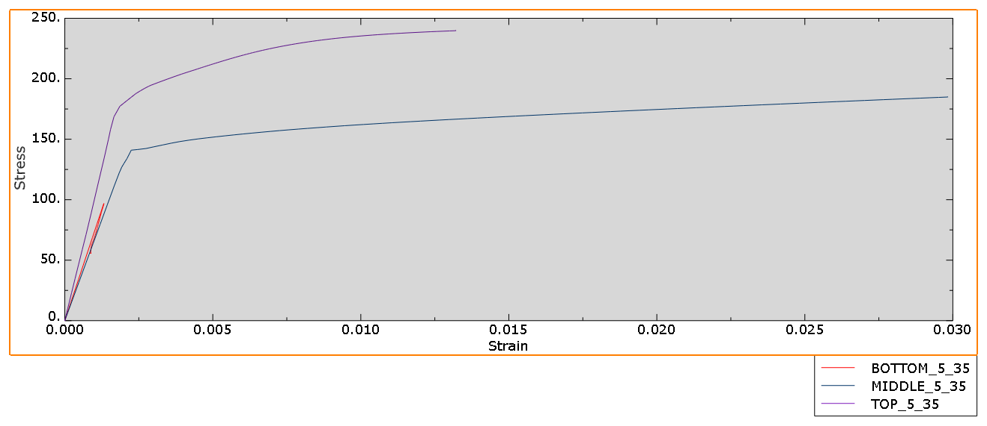

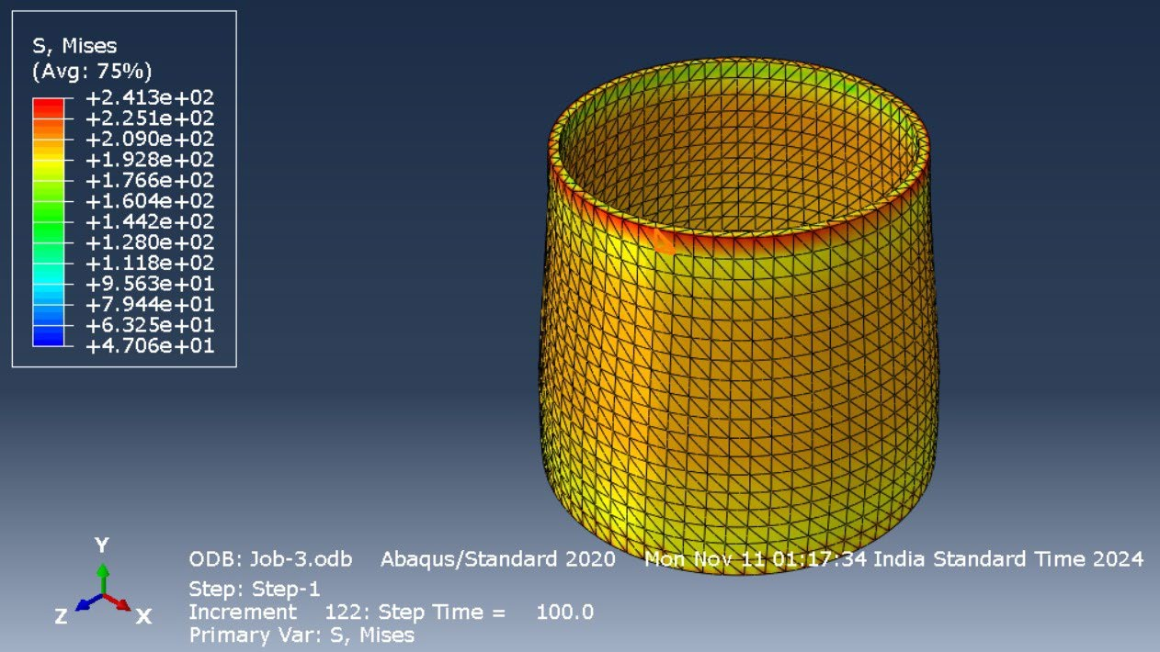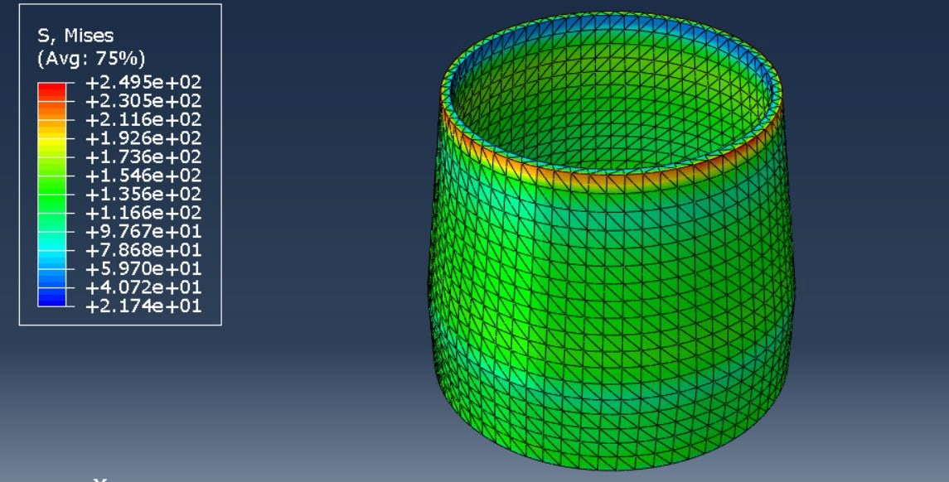

**Conclusion:**

Our report explores simulations at various locations (top, middle, and bottom) of a nozzle model to study the effects of grain size and strain rate on stress-strain responses. By comparing these plots, we observed how microstructural variations (grain size) and location impact material deformation behavior.

**Element Analysis:**

1. **Top Element**:
   * ***Grain Size Effect:*** Larger grains may lead to less grain boundary strengthening, resulting in increased ductility but lower localized strength. Smaller grains enhance boundary strengthening, increasing stress.
   * ***Location Effect*:** Positioned near the applied load, the top element experiences higher localized stress. With a fixed grain size, this element will exhibit consistently high stress for a given strain due to boundary constraints.

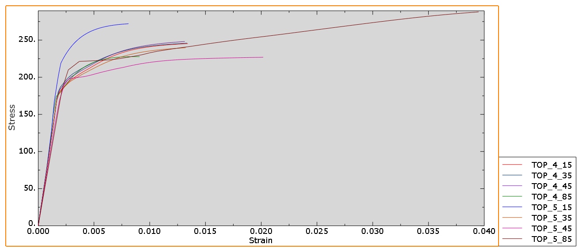

1. **Middle Element**:
   * ***Grain Size Effect*:** As an intermediate region, stress response varies with grain size but is generally more balanced than at the ends.
   * **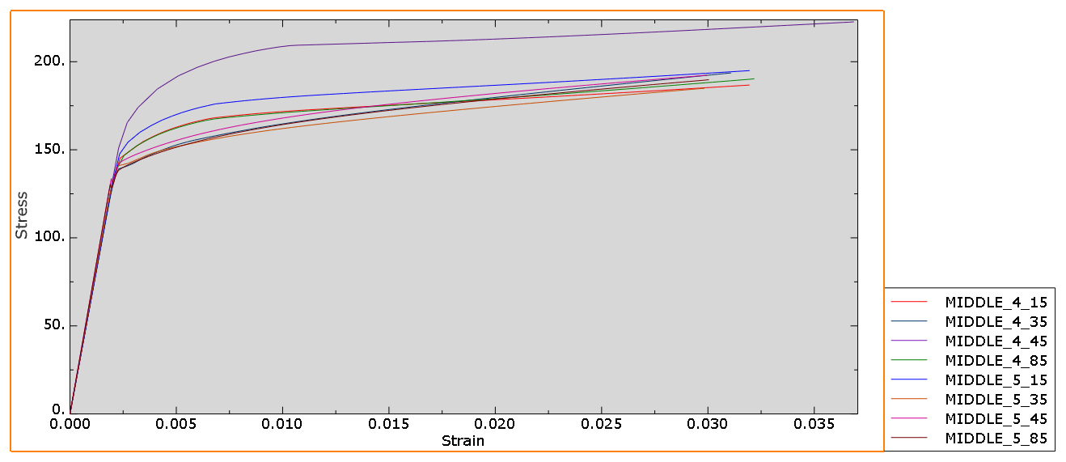*Location Effect*:** The middle element shows moderate stress levels, as it is centrally located and less influenced by boundary constraints. With fixed grain size and strain rate, it provides a balanced stress-strain distribution.
2. **Bottom Element**:
   * ***Grain Size Effect*:** Larger grains reduce stress concentration, offering higher ductility, while smaller grains increase stress response through boundary strengthening. But not going to the plastic region, instead staying in the elastic region only.
   * **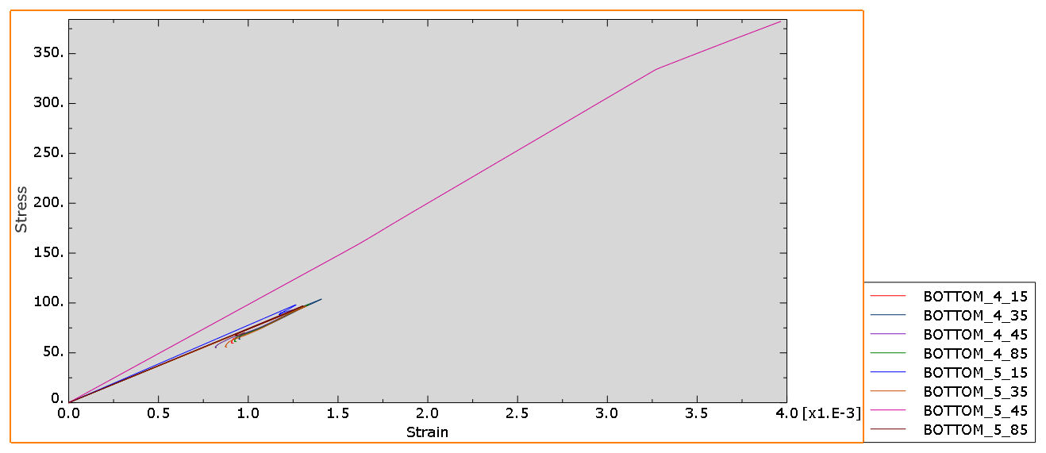*Location Effect*:** Proximity to the fixed boundary can lead to stress concentration and constraining deformation. With a fixed grain size, this region exhibits stress-strain responses dominated by boundary restrictions.

**Additional Observation**: If grain size is kept constant across varying element locations:

* **Top Element**: Highest stress response due to proximity to applied load.
* **Middle Element**: Moderate, balanced stress response due to central positioning.
* **Bottom Element**: Stress concentration near the fixed boundary reflects constrained deformation.

**Verification:**

Let’s try for a much different grain size, like in a different scale – Nanoscale. The below plot is for a 1E-4 strain rate and a grain size of 45 nanometers.

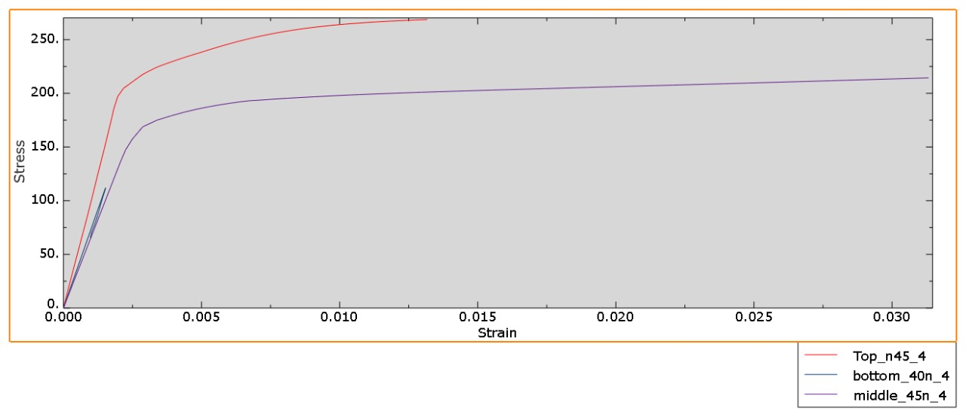The plot below demonstrates that our conclusion is also applicable at the Nanoscale also.

**Summary:**

Smaller grains create more grain boundaries, which impede the motion of dislocations (defects in the crystal structure that allow plastic deformation). As a result, materials with smaller grains are stronger, as observed in the top and middle sections.

* **Higher Strain Rates**: All elements exhibit increased stress for a given strain, influenced by location-specific boundary constraints.
* **Lower Strain Rates**: Lower stress and increased ductility across elements, with distinct location-based stress profiles.
* **Location Influence**: The top experiences maximum stress, the middle is more uniform, and the bottom shows stress concentration near fixed boundaries meaning the stress is maximum at the surface where displacement is applied and minimum at the fixed surface.